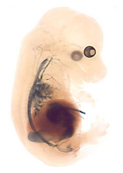

Relevant Developmental biology for lessons 1-6

Jintram@gmail.com

Lessons 1 – 6

Jintram@gmail.com

Developmental biology chapter 12 (for lessons 7-10)

Jintram@gmail.com

Lessons 7 – 10

Jintram@gmail.com

